Land Drainage Policy

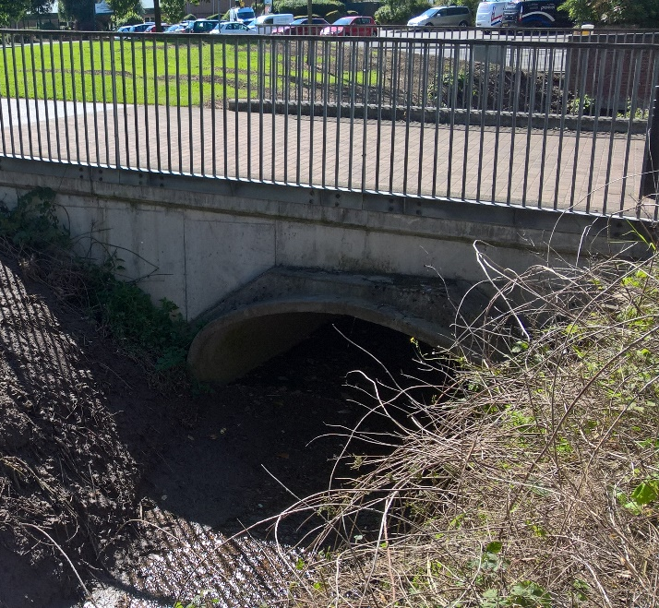
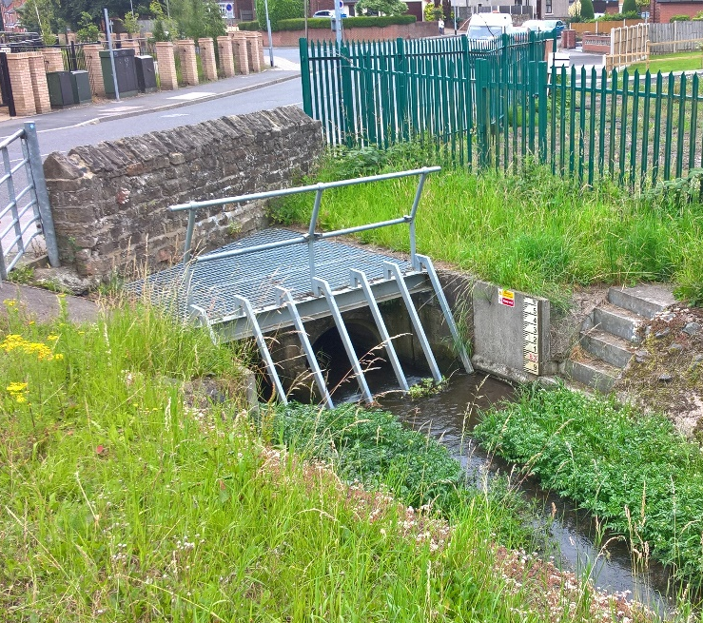

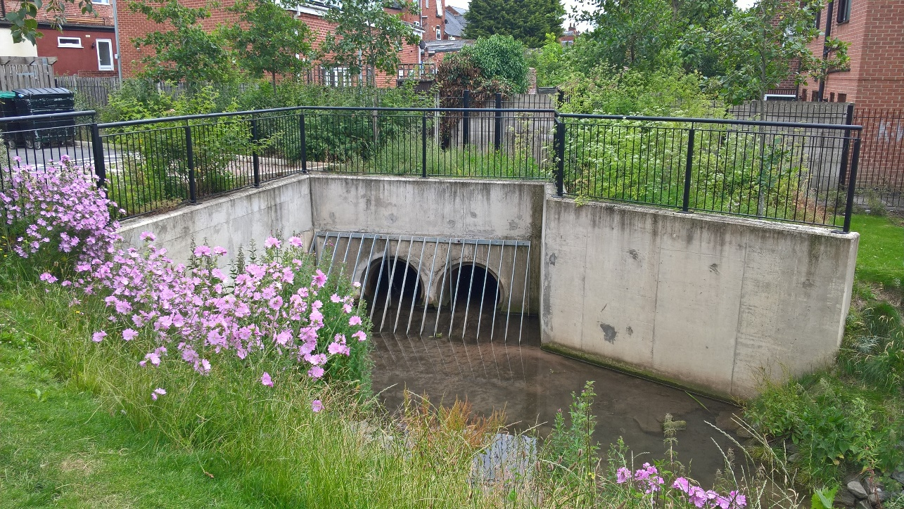

April 2020

Contents

- Introduction 3
- Legislation Context 3
- Riparian Rights 3
- Maintaining Flow 4
- Land Drainage Consents 4
5.1 Consenting Works 4
5.2 Culverts 4
5.3 Other Permissions 5
6. Unconsented Works 6
- Guidance Notes for Consent Applications 7
7.1 Introduction 7
7.2 Ordinary Watercourse 7
7.3 When is Consent Required? 7
7.4 Information Required for Consent 7
7.5 Location Plan 8
7.6 Plans and Drawings 8
7.7 Method Statement 8
7.8 Environmental Assessment 9
7.9 Maintenance 9
8.0 Application Form 9
8.1 Determination Process 10
8.2 Fast Track Service 10
8.3 Fast Track Service Fees 10
8.4 Compliance Checking 10
8.5 Compliance Checking Fees 10

1. Introduction

Nottinghamshire County Council (NCC) as the Lead Local Flood Authority (LLFA) has powers as a Land Drainage Authority to regulate watercourses in Nottinghamshire. Watercourses fulfil many roles in today’s environment. They are important features of the landscape, providing habitats for a wide variety of wildlife, drainage for developed and agricultural land, water resources and recreational value. It is therefore important that watercourses and associated habitats are protected and enhanced for the benefit of present and future generations. This policy sets out how we exercise these land drainage functions.

2. Legislative context

The Flood and Water Management Act 2010 transferred existing powers in the Land Drainage Act 1991 to regulate the proper function of ordinary watercourses to NCC. These powers consist of two parts:

- Maintaining the free flow of land drainage, including the enforcement of riparian responsibility to maintain flow in an ordinary watercourse and to maintain structures in an ordinary watercourse; and
- The power to consent and enforce structures in ordinary watercourses and changes to the alignment of ordinary watercourses. These are permissive powers, not duties, and NCC can choose to exercise them.

Within Internal Drainage Districts, it is the responsibility of the Internal Drainage Board to exercise these powers. Similarly, the Environment Agency is responsible for exercising similar powers in relation to main rivers.

NCC must also consider and apply the Water Framework Directive, which aims to prevent further deterioration and protect and enhance the status of aquatic ecosystems and associated wetlands. In order to fulfil these duties NCC will require evidence, in the form of ecological assessments appropriate to the local habitats, to demonstrate that no ecological harm will result from the works.

3. Riparian rights

Land drainage and the maintenance of flow in ordinary watercourses is the duty of riparian owners. Riparian owners are the owners of the land that a watercourse flows through. If the land on each side of a watercourse is owned by different landowners, they are each riparian owners and are responsible for the watercourse from their side to the middle of the watercourse.

Much of NCC’s land drainage role involves providing advice to land owners and neighbours about riparian rights and responsibilities, advising them of whether they need to undertake maintenance, what they need to do with any spoil from maintenance and contacting neighbours on their behalf if they need to undertake maintenance to inform them of their riparian rights.

4. Maintaining flow

NCC has powers under Sections 21 and 25 of the Land Drainage Act 1991 (as amended) to enforce riparian owners to maintain the flow of ordinary watercourses. In most cases we are able to work with land owners to achieve the desired works. However, where this approach is unsuccessful, we will consider enforcement action.

Enforcement can only be undertaken where the riparian owner has not undertaken sufficient maintenance to maintain the watercourse in a condition that can freely pass ordinary flow or has placed an obstacle in the watercourse that has not been consented. Enforcement cannot be undertaken to improve the capacity of an ordinary watercourse beyond its ordinary capacity, even if it would reduce flooding. NCC’s powers for enforcement entitle it to undertake works that are believed to be necessary if the riparian owner does not undertake such works themselves within a reasonable time.

NCC can recharge any reasonable costs incurred to do this. Prior to undertaking enforcement, NCC will advise the riparian owners of their riparian duties and recommend that they undertake the necessary work themselves.

5. Land drainage consent

5.1 Consenting works

NCC has powers under Section 23 of the Land Drainage Act 1991 to consent works in an ordinary watercourse and to enforce the removal of unconsented works. Consent is required for any works within the channel of an ordinary watercourse. These works can be permanent features such as culverts and headwalls, and temporary works to block or divert a watercourse to facilitate other activities in the watercourse. If temporary works are required to install a permanent feature, two consents will be required (one for the temporary works and one for the features that will be installed).

If there are a number of permanent features to be installed, a consent is required for each feature (they may or may not require separate temporary consents, depending on how the construction works are planned). NCC will apply the following policy in determining whether to issue a consent for a structure in an ordinary watercourse:

5.2 Culverts

A culvert is defined as ‘a covered channel or pipe which prevents the obstruction of a watercourse or drainage path by an artificial construction’ (Flood and Water Management Act 2010). Culverts may be used to convey a watercourse under a road, and they have been used to cover significant lengths of watercourse to facilitate urban development over them. It should be noted that a bridge, is a clear span across a watercourse, is not considered a culvert. Installing a culvert in an ordinary watercourse requires land drainage consent.

Nottinghamshire County Council considers it beneficial for watercourses to remain open wherever possible for both flood defence and environmental purposes. This maintains a flood channel and retains a valuable environmental feature which can enhance the site and be easily maintained. Whereas, culverting can exacerbate the risk of flooding, increase maintenance requirements and create difficulty with pollution detection. It also destroys wildlife habitats, damages natural amenity and interrupts the continuity of a watercourse. In considering any development proposals, our objective is to retain open watercourses with a corridor of open land on both sides.

Nevertheless, we understand there may be cases where culverting is unavoidable for example, short lengths for access purposes or where highways cross watercourses. Culverting will not be considered until other options have been thoroughly explored, for example:

- Clear open span bridges with existing banks and bed retained;
- Revision of site layout to incorporate an open watercourse;
- Diversion of the watercourse in an environmentally sympathetic channel and corridor.

Where culverts are unavoidable, NCC will expect them to be restricted to a minimum, a minimum of 600mm diameter and to see evidence of the hydraulic and environmental impacts of the culvert on the watercourse, and appropriate mitigation for any negative impacts. Culverts must be designed so they do not cause a restriction to flow. They must not increase the risk of flooding or prevent maintenance of the adjacent open watercourse. Consideration must also be given to overland flow paths in the event of a culvert becoming obstructed. It should be ensured that flows will not affect property or cause unreasonable nuisance or harm.

  - Other permissions

The requirement for ordinary watercourse consent is independent of the need for planning permission and the granting of planning permission does not imply or guarantee that consent will be granted. If planning permission is required it should be sought prior to land drainage consent, as the planning application may alter the site layout and consequently the nature of any ordinary watercourse works. Any consent is for the works specified in the application, including the location, if any of these details change a new consent will need to be sought.

Please provide the planning application reference where applicable in any Consent Application. Consent is also required for any works within 8m of a Main River in accordance with the Environment Agency Byelaws. If land drainage works are proposed within these boundaries, even if they are not to a Main River structure, consent from the Environment Agency will need to be sought separately.

The requirement for this can be checked here: https://www.gov.uk/guidance/flood-risk-activities-environmental-permits.

This document explains about working alongside a Main River: https://www.gov.uk/guidance/flood-risk-activities-environmental-permits#check-ifyour-activity-is-regulated Works

6. Unconsented works

Section 24 of the Land Drainage Act 1991 (as amended) also gives NCC the power to have unconsented works removed. If NCC considers unconsented works in an ordinary watercourse to be detrimental, it will commence enforcement proceedings.

There is no provision in the Land Drainage Act 1991 to issue a consent after a structure has been constructed. If the structure is otherwise acceptable and would have been issued a consent, NCC will not request that it is removed, however we cannot issue a consent for these works. It must be noted that carrying out works without consent or failing to rectify problems may be a criminal offence. Additionally, any unconsented works in which are assessed to have caused flooding or exacerbated existing flooding issues to third parties will hold appropriate liability for such.

It is advised that anyone considering any works in or near a watercourse contact the relevant authority to discuss the need for consent. NCC also has powers to undertake enforcement of structures that are constructed in a watercourse but have not been given consent. NCC will consult with local risk management authorities about consent applications that we receive or enforcement action we will take for works that do not have consent.

7. Guidance Policy Notes: Land Drainage Consent Applications & Compliance Checking

These policy guidance notes should be used to complete an application for Ordinary Watercourse Land Drainage Consent. You are advised not to carry out work on an Ordinary Watercourse without consulting the Lead Local Flood Authority (LLFA) as Land Drainage Authority. Carrying out works without consent or failing to rectify problems may be a criminal offence.

  - Introduction

Under Section 23 of the Land Drainage Act 1991, you need consent if you wish to build a culvert or structure to control the flow of water in an ordinary watercourse.

These notes provide a guide on how to complete an application for Ordinary Watercourse Land Drainage Consent. They will address the application procedure providing an overview of how to adequately provide supporting information.

  - Ordinary Watercourse

Nottinghamshire County Council is the consenting authority for works on or within close proximity to ordinary watercourses. The Environment Agency is responsible for distributing permits for works affecting main rivers.

Applicants are advised to check the Environment Agency’s Main River Maps in order to help clarify the classification of the watercourse they are interested in. These maps can be found at:

https://environment.maps.arcgis.com/apps/webappviewer/index.html?id=17cd53dfc524433980cc333726a56386

If the watercourse is identified as main river then please contact the Environment Agency with reference to your consenting works.

If you believe the watercourse is classified as ‘ordinary’ then please follow the guidance below.

  - When is consent required?

Section 23 of the Land Drainage Act states:
- No person shall-
  - Erect any mill dam, weir or other like obstruction to the flow of any ordinary watercourse or raise or other alter any such obstruction; or
  - Erect a culvert in an ordinary watercourse, or
  - Alter a culvert in a manner that would be likely to affect the flow of an ordinary watercourse
Without the consent in writing of the drainage board concerned.

Your proposed structure may not itself require consent as it does not affect the flow within the watercourse, however, the temporary works to construct the structure may obstruct the flow in order to create a dry working area. In this situation a consent application should still be made.

  - Information required for consent

The application form for applying for consent can be found at the below link:

https://www.nottinghamshire.gov.uk/media/1578/application-for-ordinary-watercourse-land-drainage-consent-v05.pdf

The amount of information supplied for the consented works in general should be proportionate to the complexity of the proposal and the flood risk associated to the locality.

As a minimum a complete application should include:
- A completed application form,
- A location plan,
- Plan and drawings of the structure(s),
- A method statement,
- An environmental assessment,
- Maintenance details; and
- Application fees.

Specific details relating to the above can be found within these guidance notes.

Please note that until all the above documents and fees have been submitted and received by Nottinghamshire County Council the determination period will not commence.

  - Location Plan

The location plan must be clear as to easily identify where the proposed works will be carried out.

This must include:
- The location of the site (at a clear scale showing appropriate boundaries),
- The name and location of any watercourse(s); and
- The easting and northing of the site.

  - Plans and Drawings

Plans and drawings should show the existing and proposed features, these should be supported by further details such as materials, flow levels, dimensions and any additional details relevant to the works.

The plans should be drawn to an appropriate scale, which must be clearly stated.

Existing Features:

You must provide plans and drawings which detail:
- The existing site and any watercourses; and
- The position and location of any existing structure which may influence the watercourse in that locality, such as dams, bridges, ways of crossing, outfalls, etc.

Proposed Features:

You must provide plans and drawings which detail:
- Cross section(s) of proposed works or structures,
- Details of existing and proposed water levels shown on cross sections or a longitudinal section of the relevant length of watercourse,
- Materials proposed for any structure; and
- Land surface contours (where appropriate)

Please note that all drawings and plans must be given a unique reference number

  - Method Statement

The Method Statement should detail how the work will be undertaken during the construction phase to mitigate any damage to the surrounding water environment.

The statement may consist of bullet points detailing how the work will be carried out in order to reduce risk. It should refer to relevant pollution prevention guidelines and how these will be incorporated into the construction phase.

The Method Statement should be site specific and not generic.

  - Environmental Assessment

We have a legal duty to protect and improve the environment, so we must consider the environmental effects of your proposal. You may need to carry out an environmental appraisal to assess the effects of your work. Failure to mitigate all the likely effect may result in your application being delay or refused.

The environmental assessment should identify all likely effects on the environment. You should consider the direct and indirect effects the work has on sites and features of interest and specific of particular value. Include any specific measures you plan to keep disruption to a minimum and reduce any unwanted effects whilst the work is being carried out. Set out any opportunities for you to improve the environmental value of the site. This may include creating water features, planting trees and shrubs that would normally grow at the site, providing bird nesting boxes or creating sustainable place for wildlife to live.

It is an offence to undertake works which adversely affect any legally protected species or habitat without appropriate measures in place under The Wildlife and Countryside Act 1981.

  - Maintenance

As part of the application we must be made aware who will be maintaining the asset during and post construction.

- Application Fees

The statutory consent fee of £50 for each structure must be sent in with the application.

This should be supplied via the online consenting process.

  - Determination Process

Upon receipt of a valid application to the Flood Risk Management Team and payment, Nottinghamshire County Council has an 8-week period in which to grant or refuse consent. In the event you need a quicker turn around on the application the council offers a Fast Track service to ensure the application can be processed within a quicker time period.

8.2 Fast Track Service

The County Council understands in some cases permission may need to be expediated as part of development plans and therefore offers a fast track service for applicants who are unable to wait the 8-week determination period.

When submitting your application please make a note or discuss with an officer in the Flood Risk Management Team that you wish for the application to be fast tracked and we will re-asses the cost of the application.

The determination period for a fast track application is 2 working weeks. This time period will begin on confirmation of receipt of all relevant documentation and fees.

8.3 Fast Track Service Fees

The Fast Track Service fee of £200 for each structure must be sent in with this application.

This should be supplied via the online consenting process.

  - Compliance Checking

Nottinghamshire County Council as part of the consenting process will undertake compliance checking to ensure structures have been installed as per the plans, designs and method statements submitted.

Within 7 days of completion of works the applicant must contact the assigned officer to arrange a compliance site check.

If compliance checking relates to temporary works the applicant must contact the assigned officer to arrange a compliance site check within 3 days of starting the works.

  - Compliance Checking Fees

The fees for compliance checking are judged on a site by site basis depending on the complexity of the application or structures. Further details of this can be found in the defined categories in Appendix 1.

This should be supplied via the online consenting process
Appendix 1

Structure Categories

- Headwalls / Outfalls
  - A visual inspection of the headwall and a CCTV inspection or evidence is required for the outfall
    - £50 per CCTV review per structure
    - £75 per visual inspection per structure
  - An onsite visual inspection will be carried out for any outfall with a diameter of 600mm or less
    - £75 per visual inspection per structure
- Culverts
  - An onsite visual inspection will be carried out for culverts less than 2m in length and with a diameter of 600mm or less
    - £75 per visual inspection per structure
  - A CCTV inspection or evidence is required for culverts greater than 2m in length or greater than 600mm diameter
    - £50 per CCTV review per structure
- Bridges
  - Any ‘bridge’ structure under 0.9m in width will require a high-level on-site survey
    - £75 per survey
  - Any ‘bridge’ structure over 0.9m in width will require a detailed survey and assessment managed by the NCC Structures team. Charges may apply dependant on complexity of structure.
- Temporary Consents
  - Any temporary consent of which impedes flow in a watercourse will require a visual inspection.
    - £75 per inspection

Notes:

- All fees and structures will be assessed on a site basis, fees may change depending on the complexity of the structure and the surrounding area.

- Mileage for officer to attend visual inspections will be charged at £0.45 per mile from County Hall.

