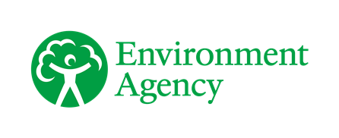

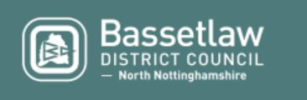
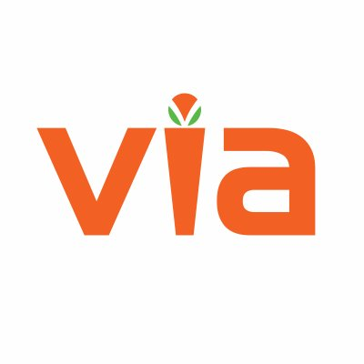
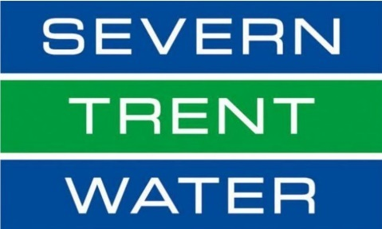

Shireoaks Flood Update

Overview and Update

In November 2019, the community of Shireoaks suffered the impact of a devastating flood event where several homes and businesses were internally flooded.

Nottinghamshire County Council, Via East Midlands, the Environment Agency, Bassetlaw District Council and Severn Trent Water are committed to investigating the causes of the flooding. They are also committed to considering potential solutions in future to reduce the risk of future flooding events.
The following information may offer some insight to questions you have about the flooding:

General Information – I have information I would like to share or would like information because I am concerned – who do I contact?

A public drop in session will be held as soon as soon as current Covid19 restrictions allow, the date and venue will be widely advertised nearer the time. Officers from each of the partner organisations will be present to assist and answer any questions that you may have. If you would like to have that discussion sooner, you can contact Officers from:

Nottinghamshire County Councils Flood Team – flood.team@nottscc.gov.uk - 0300 500 80 80

Via East Midlands - https://www.nottinghamshire.gov.uk/contact-and-complaints/contact-us/contact-us – 0300 500 80 80

The Environment Agency - enquiries@environment-agency.gov.uk - 03708 506 506 – 24hr hotline 0800 80 70 60

Bassetlaw District Council - customer.services@bassetlaw.gov.uk - 01909 533 533 (01909 534 999 out of hours).

Severn Trent Water - https://www.stwater.co.uk/help-and-contact/contact-us/ – 0800 783 4444

I have concerns about the condition of a watercourse, the River Ryton, the Public sewer or the Highway gullies/grates – who do I contact?

A watercourse or ditch - contact Nottinghamshire County Councils Flood Team – flood.team@nottscc.gov.uk - 0300 500 80 80

Highway Gullies/Grates – online at https://www.nottinghamshire.gov.uk/transport/roads/report-a-flooding-or-drainage-problem - 0300 500 80 80

The River Ryton – contact The Environment Agency - enquiries@environment-agency.gov.uk - 03708 506 506

Public sewer – contact Severn Trent Water - https://www.stwater.co.uk/help-and-contact/contact-us/ - 0800 783 4444

I have concerns about the impact that new development in or near Shireoaks is having on my risk of flooding?

There is now a focus on ensuring that all new development does not increase flood risk to both those houses being built and those existing neighbouring properties. Indeed, in most cases new development can if designed effectively reduce the risk of flooding to neighbouring communities. Nottinghamshire County Council as Lead Local Flood Authority are statutory consultees to planning process, we assess surface water drainage designs for new developments advising the Local Planning Authorities, enabling them to grant or not permission to build. Should you wish to discuss a development in or near Shireoaks please contact:

Your Local Planning Authority is Bassetlaw District Council, contact them at customer.services@bassetlaw.gov.uk - 01909 533 533 (01909 534 999 out of hours).

Nottinghamshire County Councils Flood Team – flood.team@nottscc.gov.uk - 0300 500 80 80

I have previously flooded by water from the road, would it be possible to close some of the roads in Shireoaks during flooding?

This is something that we are working towards. The Environment Agency working with Nottinghamshire County Councils Emergency Planning Team are currently looking to recruit volunteers to become Flood Wardens who amongst other tasks will be trained to put out signs and close the highway on specific roads when required. If you are interested in volunteering or would like more information, please contact:

Nottinghamshire County Councils Emergency Planning Team - emergency.planning@nottscc.gov.uk – 0300 500 80 80

The Environment Agency - enquiries@environment-agency.gov.uk - 03708 506 506

I have heard that I can apply to have my property protected against being flooded again, who do I contact?

Following the November flooding the Government made the Flood Protection Grant available to residents in Shireoaks who were flooded in their houses. This Grant pays for a contractor to survey and then protect your house from being flooded again. Bassetlaw District Council are administering this Grant and if you flooded inside your house in November 2019 and have not yet done so, you can apply here: https://www.bassetlaw.gov.uk/flooding-information/property-flood-resilience-pfr-scheme/

Contact information:
In the unfortunate event that further flooding occurs and impacts you, more information on what to do is available on the Nottinghamshire County Councils website:

Website: www.nottinghamshire.gov.uk/planning-and-environment/flooding/the-councils-role

For all other enquiries:
Phone: 0300 500 80 80
Monday to Friday: 8am to 8pm
Saturday: 8am to 12 noon

Out of Hours Phone: 01253 502776

Email: enquiries@nottscc.gov.uk
Website: www.nottinghamshire.gov.uk

Minicom: 01623 434993
Calls cost 3p/min from BT landlines. Mobile costs may vary.
Phone 0300 500 80 80 if you need the information in a different language or format.

