

**Call in Dr Bike!**

Lots of people own bikes but don’t use them.

One great way of getting people cycling is to invite a local bike mechanic (Dr Bike!) to come and examine your children’s bicycles, and get them roadworthy. This can also include teaching children cycle maintenance.

The idea of Dr Bike is that qualified mechanics carry out bicycle safety-checks and service key components, including:

* Adjusting or replacing brake blocks
* Tuning gears
* Fixing punctures

Please note: there is a cost to this service.

In Nottinghamshire and surrounding area, this service is provided by VIA East Midlands

0115 977 4373  
[road.safety@viaem.co.uk](mailto:road.safety@viaem.co.uk)

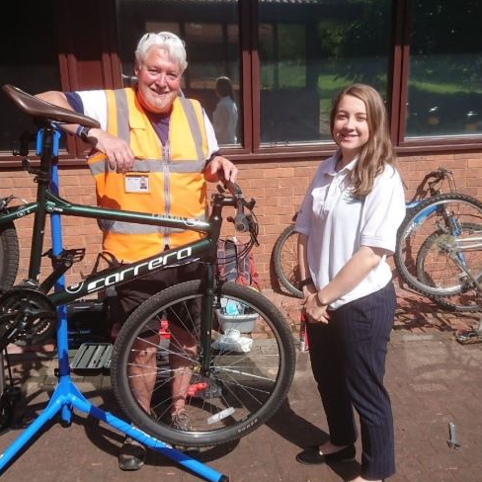

***Another idea to get kids involved in cycling is to invite the local police to come and mark bicycles. The kids will love the invisible ink!