

**Compete for the Golden Shoe!**

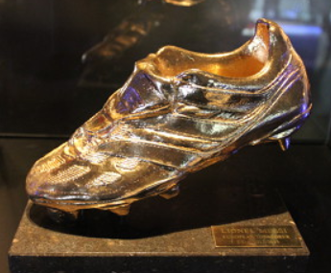

Making sustainable travel competitive (or part of a game) is a great way of getting children involved.

For younger children, a simple tally of how many walked, cycled, took public transport or car shared can be used as a competition between classes. Whoever has the most ‘green travellers’ at the end of the week will win the golden shoe!

Making a golden shoe is easy (and not that expensive!). Simply take an old shoe and mount it on a wooden board, and spray with gold paint.