

Bikes can be expensive, and therefore having somewhere to put them during the day is very important.

Position new cycle parking so that it is visible and overlooked.

We recommend the simple Sheffield (inverted U) stand.

Sheffield stands give good support, good security and multiple locking points.

They are cheap, flexible, and work for all different styles of bikes.

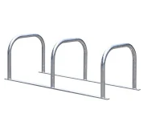

Stands that support the cycle by gripping the wheels alone, sometimes known as “butterfly stands”, should **not** under any circumstances be used