One method to highlight the issue of idling in a proactive and positive way is to launch a school “No Idling Pledge”. For this, the school writes to parents / carers asking them to “sign up” to a pledge that they will avoid idling when close to the school.

Resources needed from the school:

* Letters for all parents / carers
* Production of stickers to return to parents / carers that they can display in their cars to show they’ve signed up to the pledge. (This is even better if designed by children themselves).
* Thank you letter for parents signing the pledge

**Optional**: Banners for the school perimeter (preferably designed by children through the ‘Banner Competition’), asking parents / carers not to leave their engines running when picking up / dropping off their children.

Example resources for you to tailor to your school are provided overleaf.

SCHOOL ADDRESS

SCHOOL LOGO

Dear Parents/ Carers,

**The [INSERT SCHOOL NAME] Idling Pledge**

Idling is when a vehicles engine is left on for 30 seconds or more when the vehicle is parked / stationary. Idling emits unnecessary toxic fumes into the environment which are linked to severe health issues including cancer, respiratory issues and heart disease. It’s also bad for the environment and wastes precious natural resources (not to mention increases your weekly petrol cost!). ***The problem is worse around schools where children’s lungs are more sensitive to the toxic fumes emitted whilst idling.***

We are therefore writing to highlight the importance of preventing idling outside our school. To address this, we are launching a “No Idling Pledge” which we would like all parents/carers who drive their children to the school to sign. This is alongside several other initiatives to reduce the number of children arriving by car.

The main aim of the “No Idling Pledge” is to encourage everyone to turn off their engines when dropping / picking up children from school. This helps prevent lots of health issues for our children, including lung damage, asthma, heart disease and cancer as well as helps our environment.

Once you’ve signed up to the “No Idling Pledge”, we will send you a sticker to display in your car to show your commitment to no idling outside the school. This will hopefully encourage other drivers to do the same.

The school’s leadership team, alongside a team from Year 6 [EXAMPLE], will have the responsibility to monitor the success of your pledge and you will see them out and about at school drop off / pick up times doing their checks!

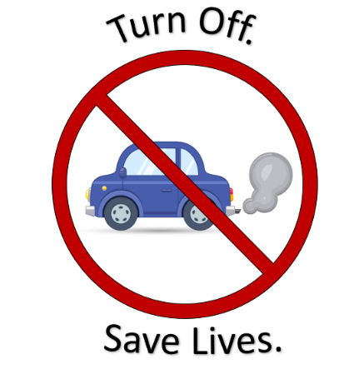

Yours Sincerely,

[NAME]

[TITLE]

[SCHOOL]

**The [INSERT SCHOOL NAME] No Idling Pledge**

I agree to:

🗸 Turn off my vehicle engine when parked or stationary for longer than 30 seconds within proximity of the school.

🗸 Help spread the importance of reducing toxic air pollution and encourage others to join the “No Idling Pledge”.

🗸 Where possible travel to school by a carbon neutral method, such as walking and cycling, to eliminate all air pollution associated with your trip (and get lots of exercise in the process!)

-----------------------------------------------------------------------------------------------------------------

REPLY SLIP

No Idling Pledge

I / We agree to support the [INSERT SCHOOL NAME HERE] No Idling Pledge to make the air cleaner and healthier for our children.

Child’s Name: ……………………………………………………..

Child’s Class: ……………………………………………………..

Parent / Carer’s Name:…………………………………………..

Signed:…………………………………………………………….