

**Dr Bike Maintenance Sessions**

Lots of people own bikes but don’t use them, or use their bikes but don’t maintain them.

As such, your school may invite a local bike mechanic (Dr Bike!) to visit the school to examine and fix students bike. The school may also incorporate this session with taught cycle maintenance sessions, so that pupils are able to look after their own bikes.

The idea of Dr Bike is that qualified mechanics carry out bicycle safety-checks and service key components at school, including:

* Adjusting or replacing brake blocks
* Tuning gears
* Fixing punctures

In Nottinghamshire and surrounding area, this service is provided by Via East Midlands

0115 977 4373  
[road.safety@viaem.co.uk](mailto:road.safety@viaem.co.uk)

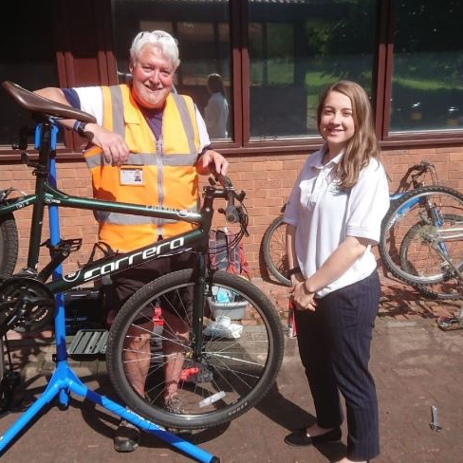

Ask the school whether they plan on running a Dr Bike maintenance session. If they are, great!- make sure your child gets involved. If not, suggest they consider running a session. Should the school be concerned with cost, try approaching local bicycle repair shops and see whether anyone would be willing to volunteer some of their time to assist.