|  |  |  |
| --- | --- | --- |
|  | Image result for nottinghamshire parent carer forum |  |

|  |  |
| --- | --- |
| **This is Nottinghamshire’s strategy for:** | |
|  | **Children and Young People with Special Educational Needs and Disabilities (SEND)**  **2024-2027** |

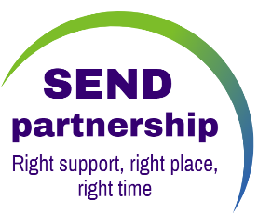

|  |
| --- |
|  |

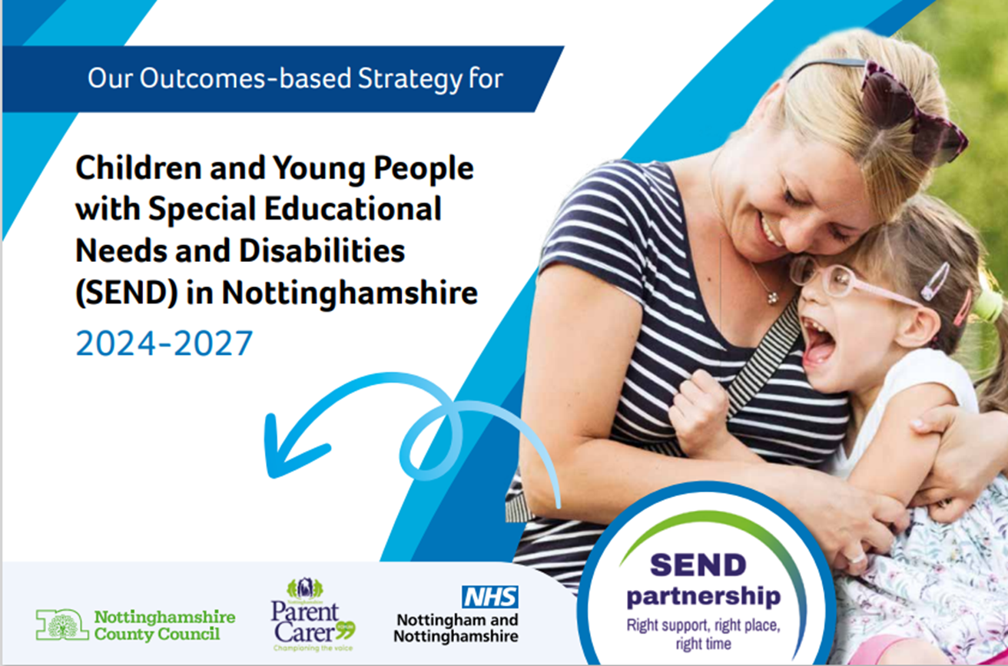

|  |  |
| --- | --- |
|  | This plan has been developed together with people including parents, carers and children and young people with SEND |
|  | We worked with people by:   * Having 7 engagement meetings that were open to everyone. * Offering people a survey to complete. * Listening to groups of children and young people in Nottinghamshire. |
|  | The plan follows 6 co-produced outcomes that we want for all children and young people with SEND in Nottinghamshire. |
| **Our 6 outcomes are:** |  |
|  | **I need to be listened to and heard.** |
|  | **I need to be the healthiest I can be.** |
|  | **I need to be safe and feel safe.** |
|  | **I need to be accepted and valued by people I trust.** |
|  | **I need to be prepared for my future.** |
|  | **I need to enjoy life and have fun.** |
|  | **I need to be listened to and heard.**  **Our actions will include:** |
|  | * Making sure people know about the advice and support that is available. |
|  | * The Nottinghamshire Parent Carer Forum will be included in the local area SEND. |
|  | * Pioneers Youth Forum will represent the views of children and young people with SEND. They are a group of young people representing and enabling young people with disabilities to have a voice and be heard. |
|  | **How will we measure progress?**  **Children, young people and their families will:** |
|  | * Give positive feedback of using health services and that they get the right help, at the right time. |
|  | * People will tell us that local SEND has listened to and responded to their views. |
|  | * People will tell us their views are heard when decisions are made about whether assessments will take place. |
|  | * Report good communications during the writing of an Education, Health and Care Plan and their views are seen in the final Plan. |
|  | * People will tell us that their EHC Plan annual review was worthwhile and on time. |
|  | * People will tell us they have been supported to prepare for their future. |
|  | **I need to be the healthiest I can be**  **Our actions will include:** |
|  | * Reducing waiting times for health therapy assessments. |
|  | * Improving transitions for young people moving into adult specialist services.   . |
|  | * Improving joint commissioning to meet the needs of children and young people.   Commissioning is how we plan, buy and provide the different services people need. |
|  | **How will we measure progress?**  **Children, young people and their families will:** |
|  | **Tell us that:**   * The right health services are there. * Their needs are met. * Waiting times are shorter. * They are getting the right help at the right time. |
|  | * Less 0- to 25-year-olds are on the support register. |
|  | * More 14–25-year-olds with a Learning Disability will have an annual health check. |
|  | * Personal health budgets will be easier to access. |
|  | **I need to be safe and feel safe.**  **Our actions will include:** |
|  | * More children and young people with SEND will attend places of education regularly. |
|  | * More children and young people will tell us that they feel safe in school and their community. |
|  | **How will we measure progress?**  **Children, young people and their families will:** |
|  | * Tell us that they feel safe accessing services. |
|  | * Tell us they get the right help at the right time from social care services and early help. |
|  | * Agree that their continuing care package meets the needs of their child or young person. |
|  | **For children and young people across Nottinghamshire, there will be:** |
|  | * Better attendance at places of education. |
|  | * It will be quicker to find Specialist placements, when they are named in an education, health, and care plan (EHCP). |
|  | * Less people being suspended and permanently excluded. |
|  | * The right support at the right time for Children and young people, who are open to children’s Social Care or the Youth Justice Team. |
|  | * Healthcare professionals with the right skills to meet the needs of children and young people. |
|  | **I need to be accepted and valued by people I trust.**  **Our actions will include:** |
|  | * More of our staff will have the right skills and knowledge. |
|  | * Reasonable adjustments across education, health, and social care. * The local area partnership promoting inclusion for SEND children and young people. |
|  | **How will we measure progress?** |
|  | * Staff will have access to training. |
|  | * Education places will be more inclusive for children and young people with SEND in Nottinghamshire. |
|  | **Children and young people will:** |
|  | * Tell us that they have more positive relationships in their lives. |
|  | * Tell us that they have a trusted adult in their education setting. |
|  | * Families will know who to contact to get the support for their child. |
|  | **I need to be prepared for my future.**  **Children and young people will:** |
|  | * Tell us that they have received positive support in their education settings. |
|  | * Receive quality education, health, and care plans (EHCPs). |
|  | * Receive their EHCP annual reviews and amendments on time. |
|  | * Have digital access to NHS Services and Technology Enabled Care. |
|  | **How will we measure progress?** |
|  | * More 2-year development health checks are completed. |
|  | * More 16 – 18-year-olds in education, employment or training. |
|  | * More children and young people will be accessing their full-time education. |
|  | **More Children, young people and their families will:** |
|  | * Have clear information to make decisions about their future and feel supported. |
|  | * Get the right support for their education and or training. |
|  | * Have their views reflected in their EHCP’s. |
|  | * Be able to safely access public transport. |
|  | **I need to enjoy life and have fun.**  **Key actions include:** |
|  | * Clear information available on community activities. |
|  | * More opportunities and better accessibility to meet the interests of children and young people. |
|  | **How will we measure progress?**  **More Children, young people and their families will:** |
|  | * Have better access to a good range of accessible activities and support in their community. |
|  | * More opportunities provided though community short breaks. |
|  | * Be involved in clubs or hobbies in school or the community. |