**Workforce Profile Report 2024**

|  |  |
| --- | --- |
| **Contents** |  |
| |  |  | | --- | --- | | **Introduction** | **2** | | **Context** | **3** | | **Data collection and definitions** | **4** | | **Profile of Nottinghamshire County Council by Protected Characteristic 2024** | **5 - 6** | | **Profile of Nottinghamshire County Council by Protected Characteristics 2023** | **7 - 8** | | **Breakdown of characteristics for Nottinghamshire** | **9** | | **Nottinghamshire County Council Recruitment Data** | **10 - 14** | | **Summary** | **15** | |  |
|  |  |
|  |  |
|  |  |

**Introduction**

The Council is committed to embedding equality, diversity and inclusion (EDI) in the delivery of its services and in the employment of its workforce. We all have a duty to comply with the Public Sector Equality Duty and the Equality Act 2010. The workforce profile information forms part of that.

We are proud of the work we have undertaken so far in striving to ensure our workplace is inclusive and our workplace practices mitigate any disproportionate impact on any staffing groups. By embracing our EDI interventions, we endeavor to develop a working environment free from bullying, harassment, victimisation and unlawful discrimination, promoting dignity and respect for all, where individual differences and the contributions of all staff are recognised and valued. All these qualities in an organisation promote a healthy workplace, with staff that can deliver the best possible services to our communities.

As an organisation we continue to deal with the effects of the pandemic, emerging equalities issues and the disproportionate impacts on certain groups and we continue to look at ways to improve our practices. The workforce profile information plays an important role in helping us to understand where any gaps exist. We use this information to inform our activity and strive to continually improve our systems, practices and processes to suit the needs of our workforce and people within Nottinghamshire.

To show due regard to the aims within the Public Sector Equality Duty we have a Corporate Equalities Action Plan which builds on successes from previous plans and drives forward the actions across our organisation. It is aligned to the themes set out within the People Strategy and the Nottinghamshire Way to promote coherence and consistency within the implementation of our EDI actions.

**Context**

The section details the Equality Act and what relevance it has, the main purpose of this report and a short summary about Nottinghamshire County Council’s (NCC) rates of sharing information across various protected characteristic strands. Nottinghamshire County Council rely on employees and applicants to give us diversity information. This information is given to us on a voluntary basis.

**The Equality Act 2010**

This report is underpinned by our duty under the Equality Act. All public sector employers, including local authorities, have a statutory duty under the Equality Act 2010 to publish the equality profile and recruitment data it holds for its directly employed workforce on an annual basis (this does not include school-based employees). The latest workforce and recruitment information for Nottinghamshire County Council (NCC) is based on data 1st April 2023 to 31st March 2024. The snapshot date is 31st March 2024.

This data underpins the Council’s commitment to ensuring that its employment practices and services are free from discrimination and prejudice and fulfil the core statutory duty placed on all public sector employers, including local authorities, to:

* monitor the profile of their workforce by the protected characteristics
* publish the relevant data on a regular basis (annually)
* identify any negative trends or issues and take any necessary action to address these.

**Purpose**

The purpose of this report is to provide an annual summary of the profile of the workforce and recruitment data for Nottinghamshire County Council by its protected characteristics as defined under the Equality Act 2010. Further information can be found using this link: Equality Act 2010: guidance - GOV.UK (www.gov.uk).

**Disclosure**

Currently, NCC employees can update their own personal data using the Employee Self Service (ESS) facility on the Business Management System (BMS). Disclosure rates for gender and age can be extrapolated from payroll data and are therefore at 100%.

The total number of employees within Nottinghamshire County Council was 7549 at 31st March 2024.

**Data collection and definitions: as of August 2024**

|  |  |  |
| --- | --- | --- |
| **Topic or Acronym** | **Definitions** | **Notes** |
| Who’s included | Permanent NCC employees | Direct employees of NCC only |
| Temporary NCC Employees |
| Who’s not included | Relief workers |
| Casual workers |
| Agency Workers |
| Protected characteristics analysed | Gender | Data self-validated by employees on an on- going basis |
| Ethnic group |
| Age |
| Disabled status |
| Sexual orientation |
| Religion/belief |
| Heads/headcount | Number of individual employees |  |
| EDI | Equality, Diversity and Inclusion | |
| BAME/BME (we aim to avoid the use of this acronym and will be used only where necessary for  data reasons) | All ethnicity categories other than British/English/Scottish/Welsh/N. Irish  BAME/BME refers to individuals from a Black, Asian and Minority Ethnic background. | |
| Disabled | Individuals who consider themselves to be disabled under the Equality Act 2010 | |
| LGBT | Lesbian, Gay, Bisexual, Transexual | |
| NCC | Nottinghamshire County Council | |
| ASCH | Adult Social Care and Health | |
| C&F | Children & Families | |
| **Period/Year** | **Source of workforce profile data** | |
| April 2012 onwards | Business Management System was introduced in 2012 | |

**Profile of NCC Employees by Protected Characteristic 2024**

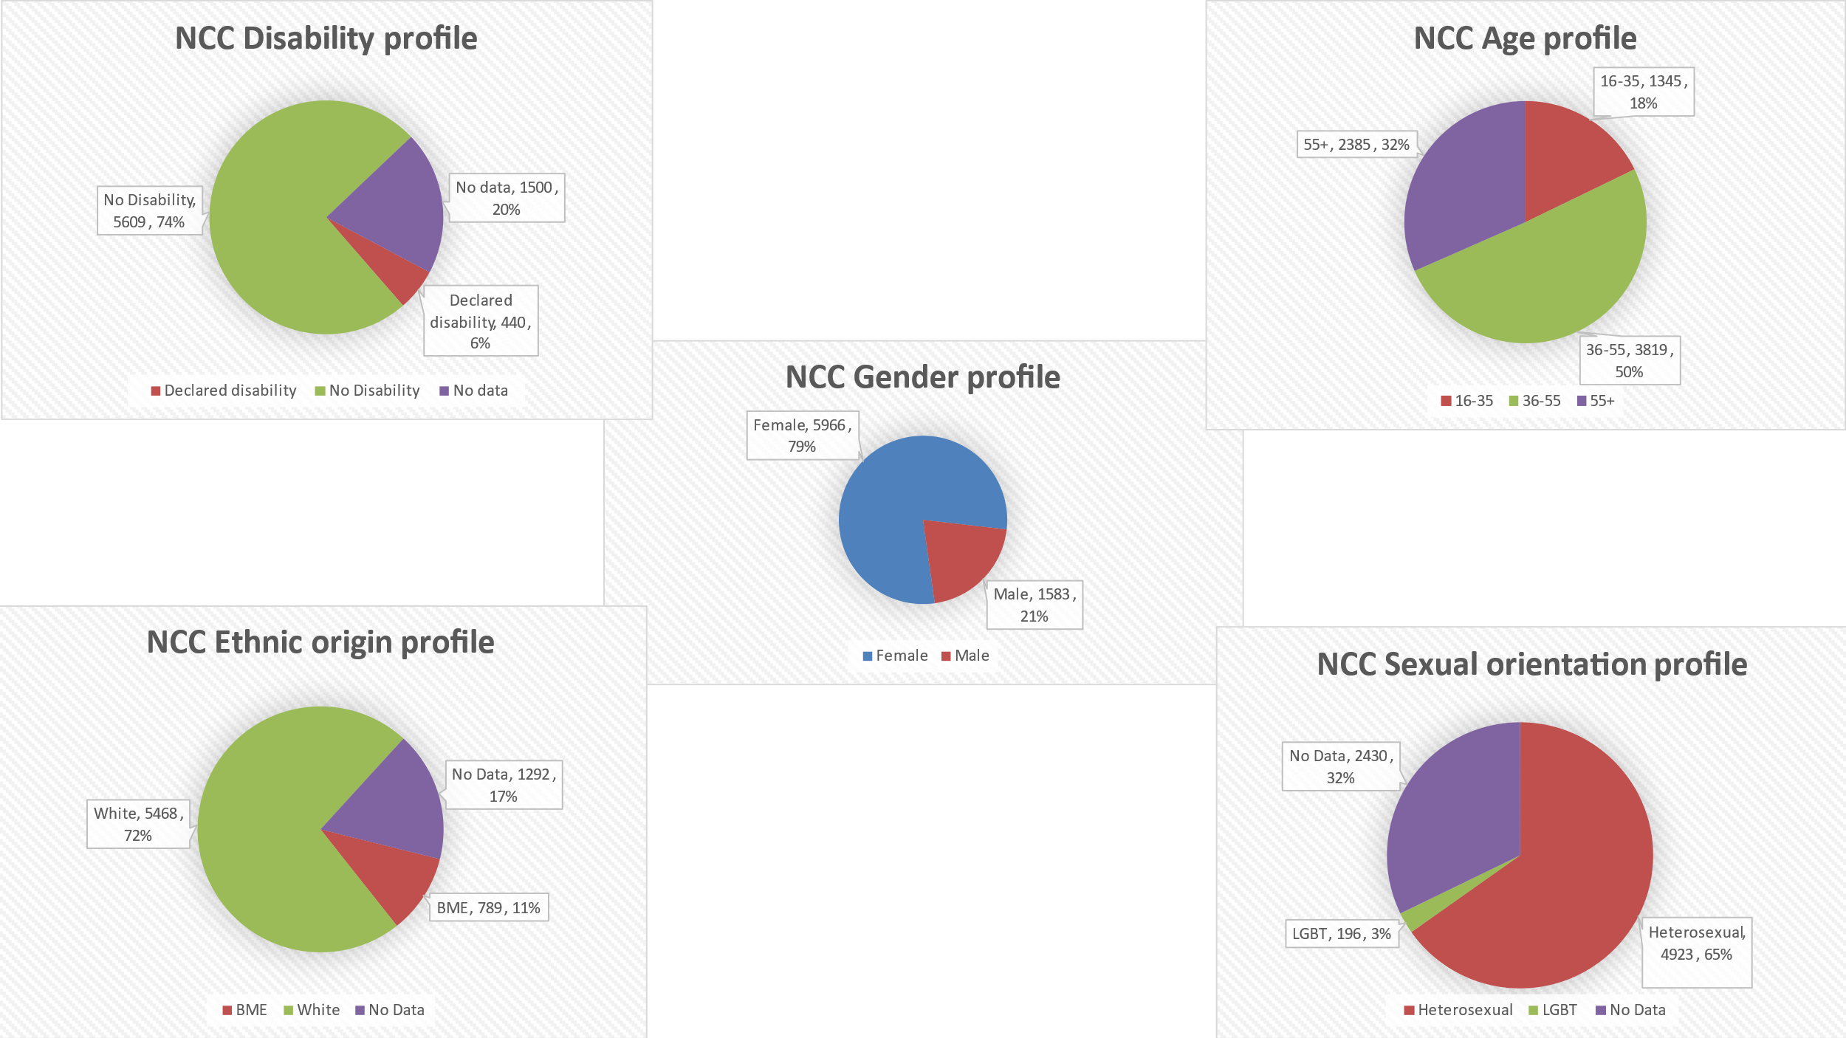

**Profile of NCC Employees by Protected Characteristic 2024**

|  |  |  |
| --- | --- | --- |
| **Percentages have been described here** | | |
| **Religion** | **Headcount** | **Percentage** |
| Christian | 2306 | 30.5% |
| Muslim | 69 | 0.9% |
| Hindu | 36 | 0.5% |
| Buddhist | 31 | 0.4% |
| Jewish | 3 | 0.0% |
| Sikh | 27 | 0.4% |
| Other religion | 60 | 0.8% |
| Other belief | 45 | 0.6% |
| No religion/belief | 2658 | 35.2% |
| Not Declared | 2314 | 30.7% |

**Profile of NCC Employees by Protected Characteristic 2023**

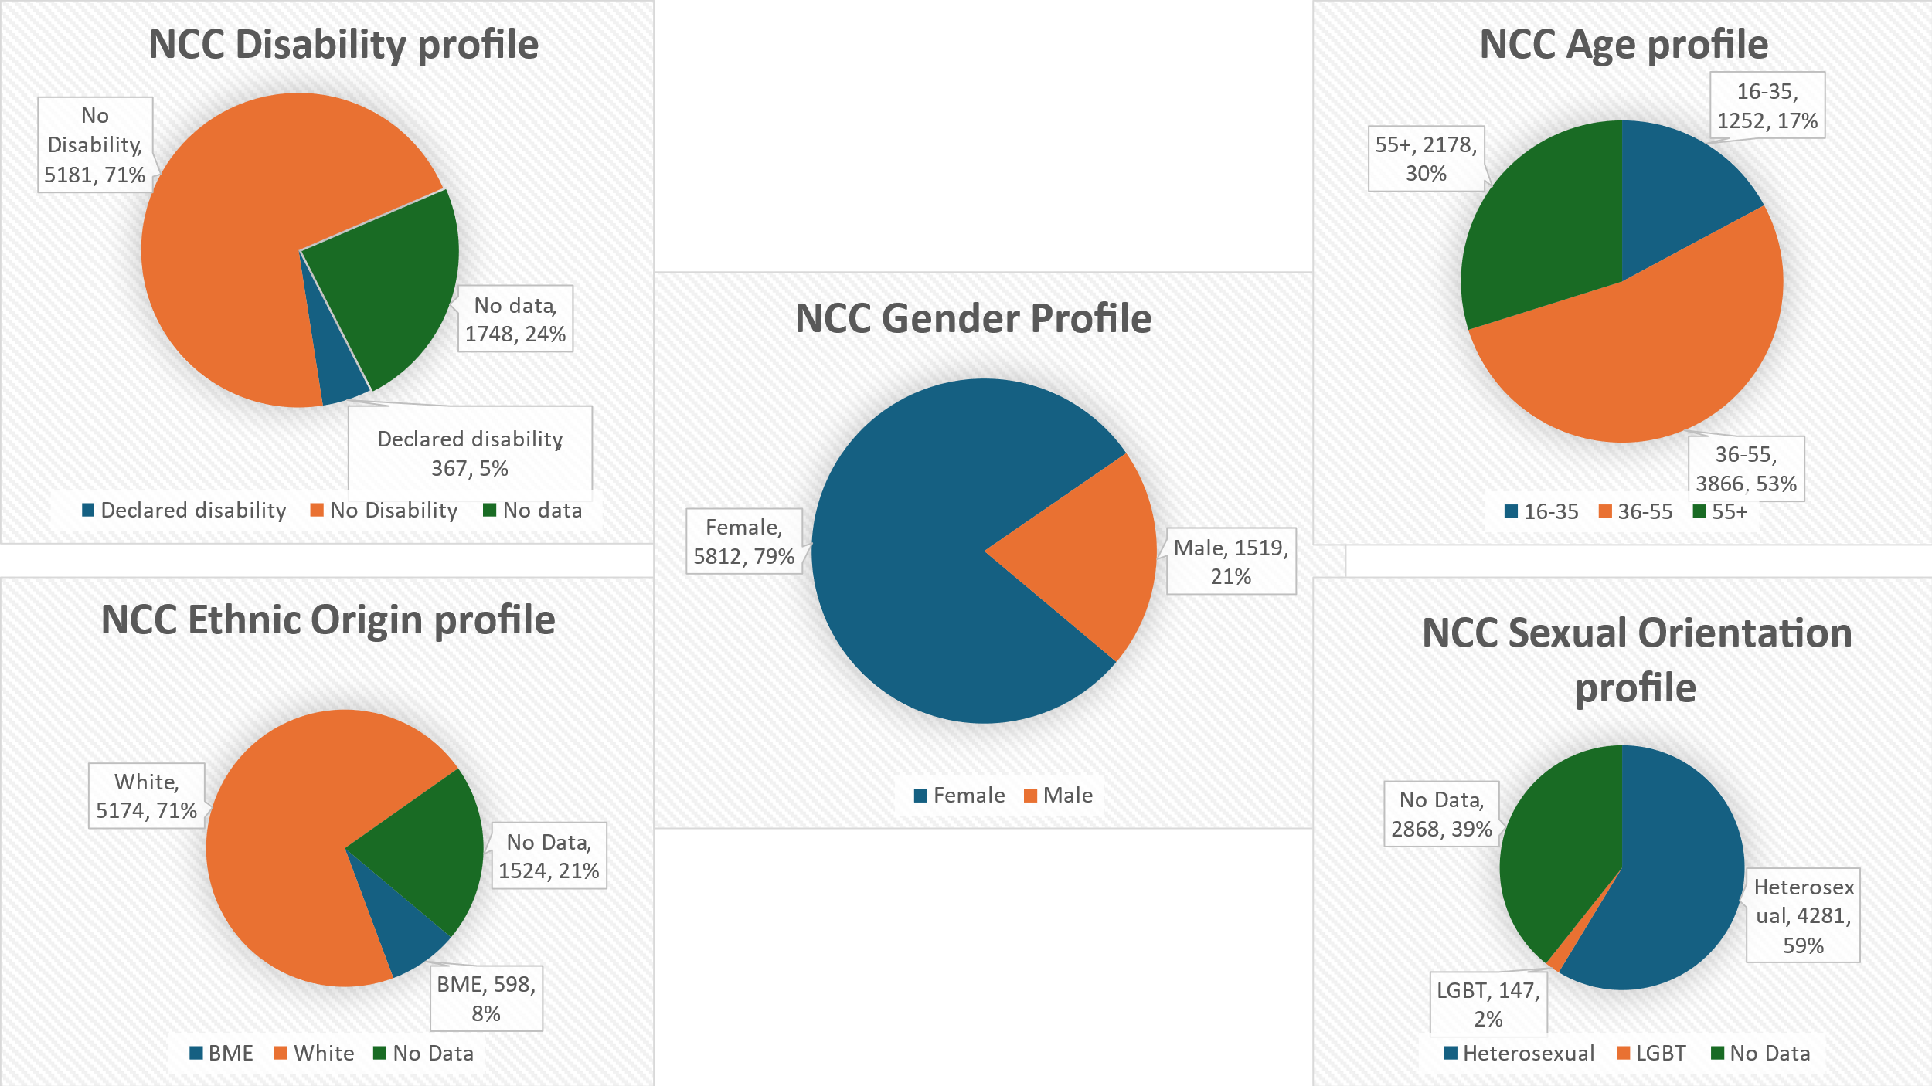

**Diversity within our workforce**

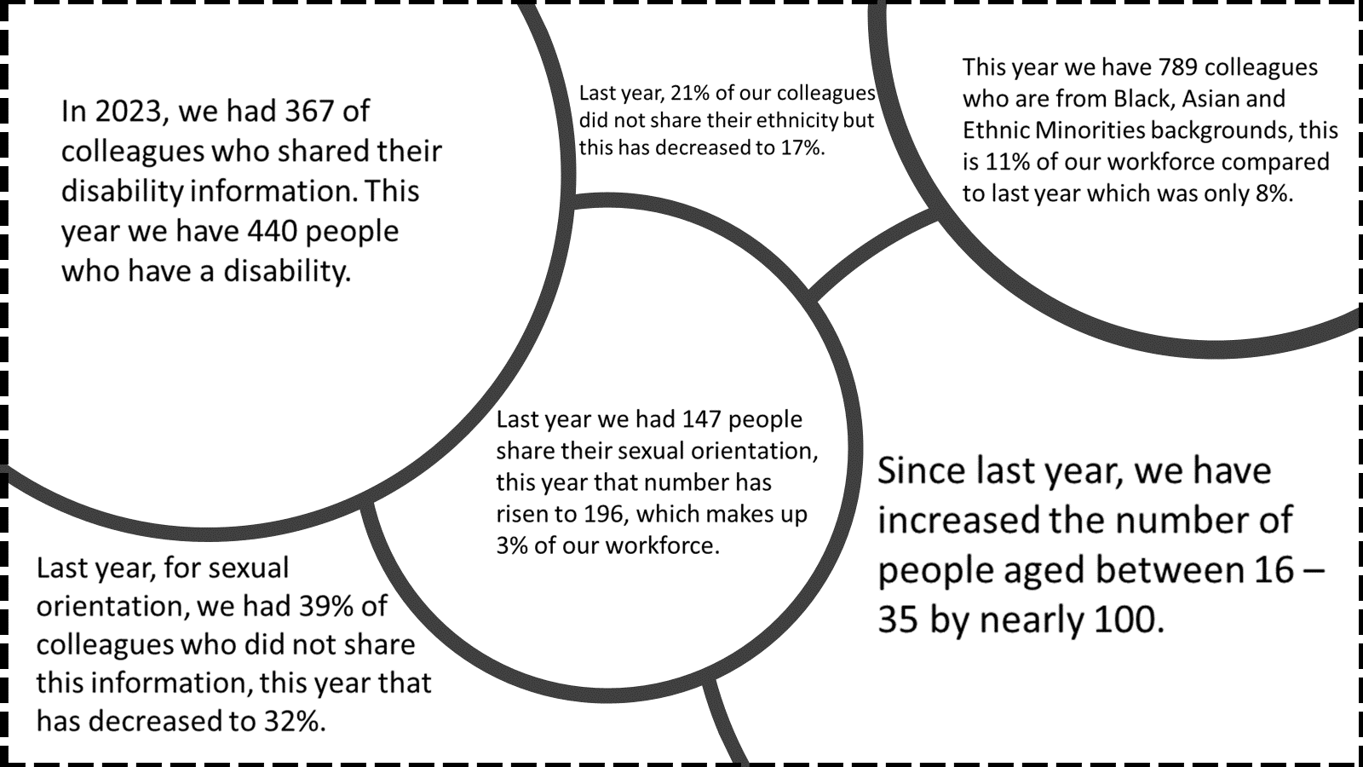

**Breakdown of characteristics for Nottinghamshire population**

Gathered from Office of National Statistics. Further information can be found [here.](https://www.ons.gov.uk/census)

|  |  |  |
| --- | --- | --- |
| **Sex** | **2021** | |
| **Number** | **%** |
| **All persons** | 824,822 | 100.0 |
| **Female** | 420,034 | 50.9 |
| **Male** | 404,788 | 49.1 |

In our council, 21% of the staff are male, while a significant 79% are female. This contrast indicates a notable gender imbalance. In Nottinghamshire, the gender distribution is more balanced, with 50.9% of the population being female and 49.1% male. This near-equal representation suggests that our council's staff composition is not reflective of the wider community, particularly the male population. We know that many factors can influence this imbalance such as the nature of our roles within NCC.

|  |  |  |
| --- | --- | --- |
| **Ethnicity** | **2021** | |
| **number** | **%** |
| **Total: All usual residents** | 824,821 | 100 |
| **Asian, Asian British or Asian Welsh** | 24,519 | 3.0 |
| **Black, Black British, Black Welsh of African background** | 5,173 | 0.6 |
| **Black, Black British, Black Welsh or Caribbean background** | 4,757 | 0.6 |
| **Mixed or Multiple ethnic groups** | 17,109 | 2.1 |
| **White** | 767,220 | 93.0 |
| **Other ethnic group** | 6,043 | 0.7 |
| **All Black, Asian and Ethnic Minority groups** | 57,601 | 7% |

Nottinghamshire's population includes a mix of various ethnic groups, contributing to its multicultural character. Approximately 7% of the population belongs to Black, Asian and Ethnic Minority backgrounds, reflecting the county's diverse nature and the unique cultural experiences of its residents. In comparison, 11% of the Nottinghamshire County Council's workforce comes from Black, Asian and Ethnic Minority backgrounds. This indicates a higher representation of Black, Asian and Ethnic Minority backgrounds communities within the council compared to the general population. Efforts are underway to ensure that our workforce is representative across various roles and grades, including within our senior leadership.

According to figures, 19% of the population in Nottinghamshire have identified themselves as disabled under the provisions of the Equality Act 2010. In contrast, 6% of the workforce population within Nottinghamshire County Council have reported having a disability. This disparity highlights an underrepresentation of disabled individuals in the council's workforce, compared to our community. suggesting a need for a more inclusive hiring approach and promotion of the support the existing available support.

NCC Recruitment data 2024

We believe we are an equal opportunities employer. This means we are committed to hiring and treating all employees in an equitable way. Our hiring process and policies mean that hiring conditions are fair and accessible for minority groups to express their full potential at each stage of the process. From our recruitment database we have provided figures for the application, shortlisting and offer stages of recruitment. We have examined these figures across the protected characteristic groups i.e., Gender; Ethnic Origin, Sexuality; Religion or Belief and Disability. Data collection is based on information from 1st April 2023 – 31st March 2024. (Percentages have been rounded up or down therefore totals might equate to just below or over 100%).

For each protected characteristic there is a breakdown of information showing the % of candidates at each stage of the process.

Gender

65% of applications were from female candidates, 34% were from male candidates.

Out of all those candidates interviewed, 72% were female, 28% were male and 1% preferred not to share their gender or described their gender as something apart from male or female.

Of all those individuals that we made formal offers to 79% were female and 21% were male and 1% preferred not to share their gender or described their gender as something apart from male or female. We acknowledge that there is an imbalance in our workforce gender split. However, it is of paramount importance to us that we focus on maintaining a fair hiring process that actively avoids gender bias and discrimination. Our commitment is to evaluate all candidates on an equitable platform.

Ethnicity

BME refers to individuals from a Black, Asian and Minority Ethnic background as explained on page 3.

62% of applications were from White candidates, 34% were from a Black, Asian and Minority Ethnic background. For 4% of candidates, we had no information on ethnicity.

Of the candidates selected for interview, 73% were White, 24% were from a Black, Asian and Minority Ethnic background. For 3% we had no information on ethnicity.

Of those individuals we made formal offers to, 83% were White, 15% had a Black, Asian or Minority Ethnic background. For 2% we had no information on ethnicity.

Data shows disparities in the progression rates of candidates from different ethnic backgrounds. White candidates have higher success rates at each stage, leading to more job offers. In contrast, Black, Asian and Ethnic Minority candidates experience a noticeable drop-off as they advance through the hiring process. Activity through our corporate equalities action plan such as implementation of diverse panel members and blind recruitment within our shortlisting processing is addressing the current disproportionate effect.

Sexuality

Out of all the candidates that submitted applications 90% said that they were Straight/Heterosexual. 1% identified as Gay men, 3% said that they were Bisexual and 1% said that they were Lesbian. 5% of those who submitted applications did not share their sexuality or they are self-described.

91% of candidates that were selected for interview identified as Straight/Heterosexual. 1% identified as Gay men, 2% said that were Bisexual and 1% identified as being Lesbian. 4% of those selected for interview did not share their sexuality or they are self-described.

Out of all the candidates we made a formal offer to 92% said that they were Straight/Heterosexual. 1% identified themselves as Gay men, 2% said they were Bisexual and 1% identified as Lesbian. 4% of those who we made formal offers to did not share their sexuality or self-described.

Religion

Out of all the applications submitted, 1% stated they were from the Christian faith. 16% were from faiths other than Christianity and 83% had no belief.

Out of all the applicants selected for interview, 1% were from the Christian faith, 12% of applicants were from faiths other than Christianity and 88% had no belief.

Out of the candidates that we made a formal offer to, no one was from the Christian faith, 7% were from faiths other than Christianity and 92% had no belief.

There is a further breakdown by religion below:

|  |  |  |  |  |  |  |  |  |  |  |
| --- | --- | --- | --- | --- | --- | --- | --- | --- | --- | --- |
|  | Other belief | Other religion | Sikh | Muslim | Jewish | Hindu | Buddhist | Christian | Prefer not to share | None |
| Applications submitted | 4% | 0% | 1% | 1% | 0% | 5% | 5% | 1% | 37% | 46% |
| Selected for interview | 3% | 0% | 1% | 1% | 0% | 3% | 3% | 1% | 37% | 51% |
| Formal Offer Made | 3% | 0% | 1% | 1% | 1% | 0% | 1% | 0% | 37% | 56% |

Disability

Out of all the candidates that submitted applications, we had no information in relation to disability for 2% of individuals. 7% of candidates shared that they had a disability and 91% said that they did not have a disability.

Of all the candidates that were selected for interview, for 3% we had no information in relation to disability. 8% shared that they had a disability and 89% said that they did not have a disability.

Of candidates we made formal offers to, for 4% of these we had no information in relation to disability. 8% of candidates shared that they have a disability and 87% said that they did not have a disability.

While data shows that individuals with disabilities are moving through the recruitment process proportionately, there is still a low level of initial applications from this group. Once people with disabilities apply, they progress through the stages similarly to non-disabled candidates. The main barriers seem to occur at the initial application stage.

Summary of workforce profile information and what we are working on to uphold and advance our Equality Duty.

The data demonstrates that we have diversity within our workforce, and we are extremely proud of this. We appreciate that our workforce data is dependent upon voluntary disclosure of information, and this is something we have worked on to improve through activity such as “Diversity December”, which proved successful. Reviewing the recruitment data, there is some minor disproportionate impact from application to offer stage across some of the characteristics and we continue to work on a number of actions we have in place, such as anonymous application forms and delivering our “Treating People Fairly” mandatory course, which includes fair recruitment practices. In addition, this year we are focusing on engaging our managers using an intervention that will mean they have access to support and guidance from our underrepresented groups of colleagues, who will share their lived experience and act as a sounding board to increase awareness and improve practice. We work closely with our self-managed networks and trade unions across all departments on our equality action plan activity aimed at improving inclusion, equality, and diversity across our workforce and in the community. Some of the activity undertaken this year has included rolling out our reverse mentoring programme to include more mentors from all our networks, continuing to progress our work on employee passports and embed learning from our brand-new learning and development program for our leaders, as well as continuing to offer in person EDI training. We provide a range of health and wellbeing support initiatives and promote a range of events that support all protected characteristics and beyond. After increasing our cohort of Mental Health First Aiders, we are working to embed relevant wellbeing activity across all four departments consistently to ensure we reach all our colleagues.

We continue our commitment towards race equality as we work with Skills for Care to deliver the Workforce Race Equality Standard project. Our priority with learning and development has been to improve skills across Nottinghamshire and provide a range of opportunities for all staff, with a focus on supporting young people through apprenticeships, graduate programs, work experience and our Summer Intern Program to support individuals with disabilities. Our Skills, Development and employment opportunities strategy sets out our Corporate Parenting commitment to supporting Looked After Children and care leavers in Nottinghamshire, to find appropriate employment with industry linked learning and development that meets their individual aspirations.

Our corporate equality action plan will be informed by data sources such as the workforce profile, and will be underpinned by our NCC People Strategy, linked to the values and behaviours embedded in the Nottinghamshire Way and be guided by our employee network to reflect the voice of diverse workforce. This will enable us to continue to uphold our duty under the Equality Act 2010.