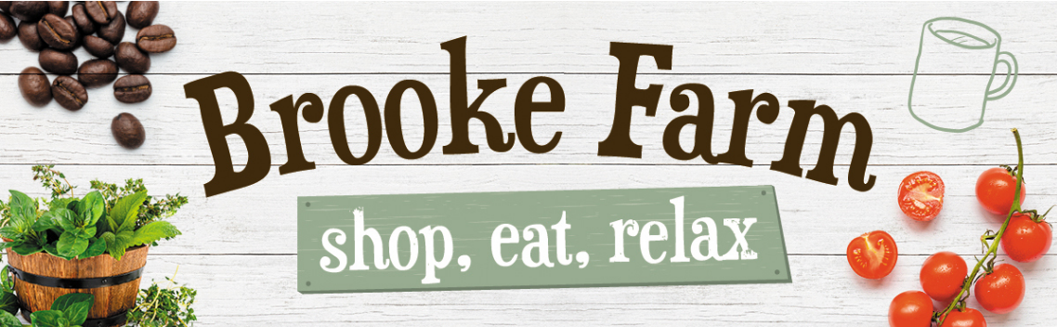

**Drinks**

Latte * £2.85

Americano* £2.85

Cappuccino * £2.85

Flat White £2.85

Mocha £2.85

Espresso £1.85

*Decaf Options Available

Hot Chocolate £2.85

Luxury Hot Chocolate £3.20

Served with Cream and Marshmallows.

Babyccino £1.75

Hot Milk served with a Dusting of Chocolate

and a large marshmallow.

Iced Coffee £2.85

Espresso served over Iced milk with a hint of Vanilla.

Can be served with or without cream

Coffee Syrups £0.50

Vanilla

Caramel

Warm spice

Pumpkin spice

Irish cream

Chocolate orange

Chai

Pot of Tea * £2.75

Pot of Herbal tea £2.75

English Breakfast

Sapphire Earl Grey

Dragonwell Green Tea

Egyptian Mint

Citrus Chamomile

White Pear & Ginger

Wild Encounter

Persian Pomegranate

Organic Darjeeling

Organic Jasmine

Shmoo Milkshakes Small £2.00

Large £3.00

Vanilla, Banana Chocolate and Strawberry

**Breakfast**

served from 10.00am till 12.00pm

Small breakfast £6.95

1Sausage, 1 Bacon, 1 Fried Egg,

1 Hashbrown, Mushrooms, Beans, and a Slice of Toast with Butter

Large English Breakfast £8.95

2 Sausage, 2 Bacon, 1 Fried Egg,

2 Hashbrown, Mushrooms, Beans and 2 Slices of Toast with Butter

Bacon Cob £3.50

Sausage Cob £3.50

Sausage & Bacon Cob £4.50

Bacon & Fried Egg Cob £4.50

Sausage & Fried Egg Cob £4.50

Bacon & Mushroom Cob £4.20

Sausage & Mushroom Cob £4.20

Vegan Sausage Cob £3.50

2 Slices of Toast with Butter £1.95

Beans on toast £3.95

2 Slices of Toast & Beans

Scrambled egg on toast £3.95

2 Slices of Toast & Scrambled Eggs

Toasted Tea Cake £2.45

Toasted tea cake with butter

Pancakes

Pancake Stack

A Stack of 5 American Pancakes served with a pot of Maple Syrup or Jar of Jam £3.95

Pancake Stack with Bacon

A stack of 5 American Pancakes served with Streaky Bacon and a pot of Maple Syrup £4.95

Fruit Scone £2.50

Scone Served with Butter

Cheese Scone £2.50

Scone Served with Butter

Sweet Scone Special £4.10

Fruit Scone Served with Butter, Clotted Cream and Jam

Savory Scone Special£4.10

Cheese Scone Served with Butter, grated cheese and pickle portion

Hot Sausage Roll £2.75

Beef & Vegetable Pasty £2.95

Cheese & Onion Pasty £2.95

Vegan Sausage Roll £2.50

**Lunch**

served from 12.00pm

Panini & Toasties

Served with a salad garnish a pot of coleslaw and crisps

Toasties £6.75

Cheese & Onion Toasties

Ham & Cheese Toasties

Tuna & Cheese Toasties

Panini £6.25

Ham & Cheese Panini

Cheese & Tomato Panini

Chicken Tikka Panini

Cheese & Tomato Arrabbiata Meatball Panini

Caprese, Mozzarella, Tomato & Pesto Ciabatta Pulled Pork Mozzarella Ciabatta

Al Funghi Ciabatta

Jacket Potato

Served with a salad garnish a pot of coleslaw

Jacket with 1 filling £6.75

Choice of 1 filling:

Beans, Cheese or Tuna

Extra jacket fillings £1.50

Choice of fillings:

Beans, Cheese or Tuna

Soup of the Day

served with a bread roll and butter.£4.95

Pancakes

Pancake Stack

A Stack of 5 American Pancakes served with a pot of Maple Syrup or Jar of Jam £3.95

Pancake Stack with Bacon

A stack of 5 American Pancakes served with Streaky Bacon and a pot of Maple Syrup £4.95

Fruit Scone £2.50

Scone Served with Butter

Cheese Scone £2.50

Scone Served with Butter

Sweet Scone Special £4.10

Fruit Scone Served with Butter, Clotted Cream and Jam

Savory Scone Special£4.10

Cheese Scone Served with Butter, grated cheese and pickle portion

Hot Sausage Roll £2.75

Beef & Vegetable Pasty £2.95

Cheese & Onion Pasty £2.95

Vegan Sausage Roll £2.50