

**O2 Public Wi-Fi: Quick Start Guide**

**External Users ONLY** – Laptops and Tablets

**NCC Staff** – Smart Phones **BUT NOT** NCC Laptops

**How to connect:**

**New user:**

Select the ‘O2 Wi-Fi’ network in the Wi-Fi settings

on your device. Open your internet browser and

follow the registration instructions:

**Step one:**

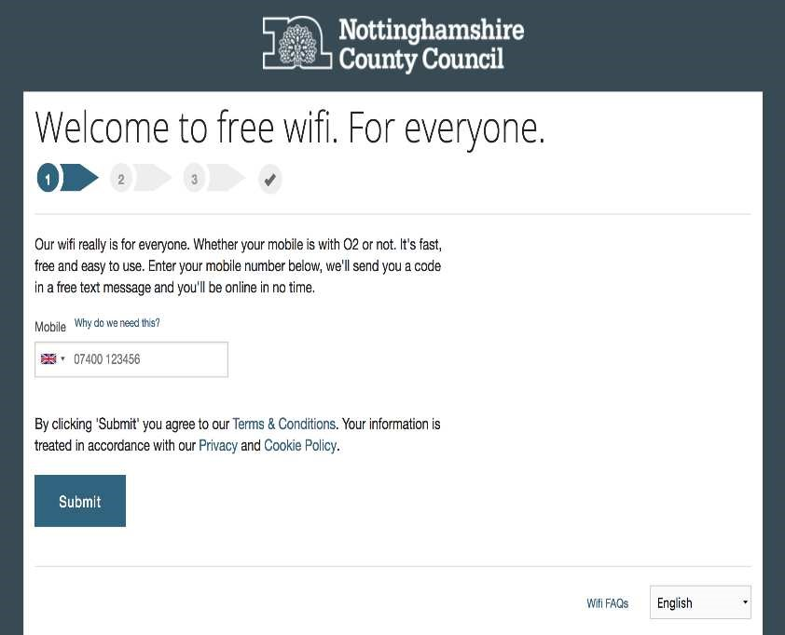

**Step two:**

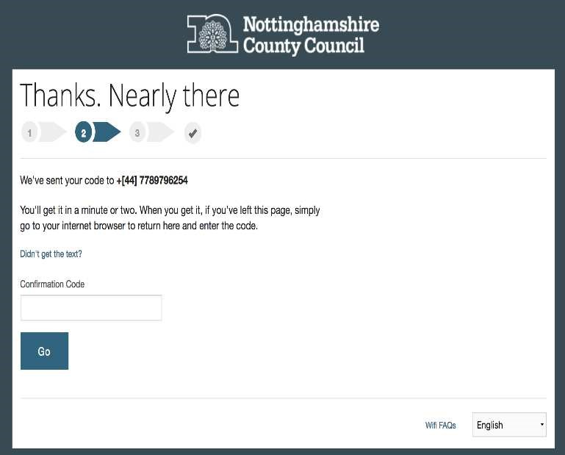

**Step three:**

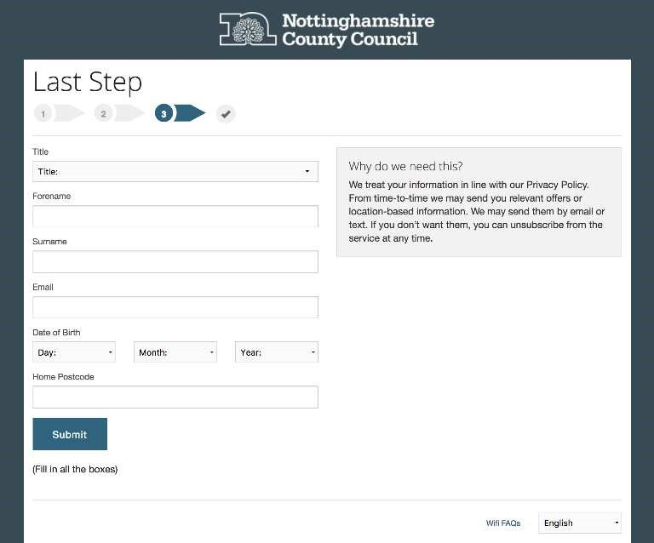

**Welcome:**

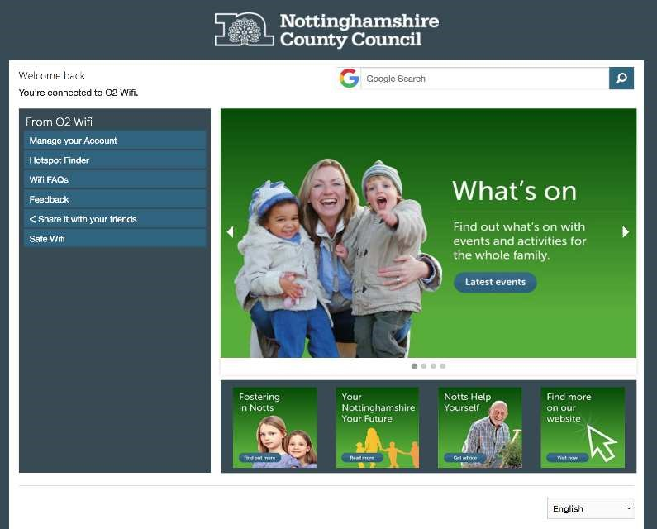

**Already registered with O2?**

If you have previously registered with O2, you will

connect automatically to O2 Wi-Fi once selected in

your Wi-Fi settings.

If you experience any difficulty in connecting to the

Wi-Fi, please contact O2 in the first instance:

Tel:

**0800 6523123**

Internet: www.o2.co.uk/connectivity/free-wifi